Technical Report: Keypad Calculator Implementation
By:Jaudat Al-Hussein &Omar Al-Khayat

Project Overview
This code implements a basic single-digit arithmetic calculator using a 4x4 keypad and 16x2 LCD display. The system performs addition, subtraction, multiplication, and division operations with result display on both LCD and serial monitor.

Hardware Configuration
Component | Connection Details | Purpose
LCD Display | RS:A1, E:A2, D4:13, D5:12, D6:11, D7:10 | Primary output interface
Contrast | Pin A0 (PWM) | LCD contrast control
Keypad | Rows:9,8,7,6; Columns:5,4,3,2 | User input interface
Microcontroller | Arduino Uno (implied) | Main processing unit

Key Functional Specifications
- Input Handling:
  - Strict 3-step operation sequence: [Number] → [Operator] → [Number]
  - Operators mapped to keypad letters:
[A = + | B = - | C = * | D = /]
- Display:
  - Real-time expression building on LCD
  - Results displayed immediately after second operand entry
  - Serial monitor duplicates all operations for debugging
- Reset Mechanism:
  - [*] key triggers full system reset at any time
  - Automatic reset after calculation completion

Critical Limitations
- Single-Digit Only
- No division-by-zero protection
- No parentheses or operation chaining

Full Code Analysis

1.Required Libraries and Basic Settings
#include <Keypad.h> // Allows the Arduino to read button presses
#include <LiquidCrystal.h> // Lets the Arduino talk to the screen

int Contrast = 120; // Controls how dark/light the screen text appears
LiquidCrystal lcd(A1, A2, 13, 12, 11, 10); // Connects the screen to specific Arduino pins

What this does
This loads the necessary software tools. The Contrast setting makes the screen readable, and the lcd line tells the Arduino which physical pins connect to the display screen.

2.Calculator Memory Setup
const byte ROWS = 4; // Keypad has 4 rows of buttons
const byte COLS = 4; // Keypad has 4 columns of buttons
int expr[2]; // Stores two numbers (like "5" and "3")
int i = 0; // Tracks which step we're on (first number, operator, etc.)
char op; // Stores the math symbol (+, -, *, /)
What this does
This sets up the calculator's "memory":
- expr[0] holds the first number you type (e.g., 5)
- expr[1] holds the second number (e.g., 3)
- op remembers the math symbol you chose (like +)
- i is like a step counter:
0 = "Waiting for first number"
1 = "Waiting for [+, -, *, or /"]
2 = "Waiting for second number"

3.Reset Function
void resetCalc() {
Serial.println(); // Adds a blank line in the computer log
i = 0; // Resets step counter to the beginning
lcd.clear(); // Wipes the screen clean
lcd.setCursor(0, 0); // Moves cursor to the top-left corner
}

What this does
When you press [*] or after a calculation finishes, this:
- Clears the screen
- Forgets the numbers and math symbol you entered
- Prepares the calculator for a new problem
(It’s like pressing the "C" button on a regular calculator)

4.Keypad Layout
char hexaKeys[ROWS][COLS] = {
{'1', '2', '3', 'A'},
{'4', '5', '6', 'B'},
{'7', '8', '9', 'C'},
{'*', '0', '#', 'D'}
};
byte rowPins[ROWS] = {9, 8, 7, 6};
byte colPins[COLS] = {5, 4, 3, 2};
Keypad customKeypad = Keypad(makeKeymap(hexaKeys), rowPins, colPins, ROWS, COLS);

What this does
- Buttons A, B, C, D perform math operations:
A = + (Add)
B = - (Subtract)
C = * (Multiply)
D = / (Divide)
- * = Clear everything
- # = Not used in this version (but the startup message mentions it)

5.Startup Instructions
void setup() {
Serial.begin(9600); // Starts communication with computer (for debugging)
analogWrite(A0, Contrast); // Sets screen contrast
lcd.begin(16, 2); // Initializes the 16-character wide, 2-line screen
lcd.noCursor(); // Hides the blinking text cursor
lcd.setCursor(0, 0); // Starts text at top-left of screen

// Shows welcome messages on computer screen (not on LCD):
Serial.println("Welcome to keypad Calculator");
Serial.println("A = +, B = -, C = *, D = /");
Serial.println("Press # to calculate"); // Note: This is outdated - calculation happens automatically
Serial.println("Press * to reset");
Serial.println("NOTE: It works only on single digit numbers\n\n");
}

What this does
When powered on, this:
- Prepares the screen
- Sends instructions to the computer (visible in Arduino software’s "Serial Monitor"):
  - Explains button meanings (A=+, etc.)
  - Warns that only single-digit numbers work (e.g., 5 but not 12)
  - Notes that * clears everything (important: # doesn’t actually calculate anything)

6.Main Operation Logic
void loop() {
char key = customKeypad.getKey();

if (key) {
if (i == 0) {
expr[0] = key - 48;
Serial.print(expr[0]);
lcd.print(expr[0]);
i++;
}
else if (i == 1) {
op = key;
i++;
if (op == 'A') { Serial.print(" + "); lcd.print(" + "); }
else if (op == 'B') { Serial.print(" - "); lcd.print(" - "); }
else if (op == 'C') { Serial.print(" * "); lcd.print(" * "); }
else if (op == 'D') { Serial.print(" / "); lcd.print(" / "); }
else {
Serial.println("Syntax error");
lcd.print(" Syntax error ");
resetCalc();
}
}
else if (i == 2) {
expr[1] = key - 48;
Serial.print(expr[1]); lcd.print(expr[1]);
Serial.print(" = "); lcd.print(" = ");
if (op == 'A') { Serial.println(expr[0] + expr[1]); lcd.print(expr[0] + expr[1]); }
else if (op == 'B') { Serial.println(expr[0] - expr[1]); lcd.print(expr[0] - expr[1]); }
else if (op == 'C') { Serial.println(expr[0] * expr[1]); lcd.print(expr[0] * expr[1]); }
else if (op == 'D') { Serial.println(expr[0] / expr[1]); lcd.print(expr[0] / expr[1]); }
i++;
}
else if (key == '*' || i == 3) {
resetCalc();
}
}
}

What this does
This works in 4 steps:
- First number: You press 5 → screen shows 5
- Math symbol: You press A → screen shows 5 +
- Second number: You press 3 → screen shows 5 + 3 = → immediately shows result 8
- Reset: After showing the result, the next button press (or pressing * anytime) clears everything.

Circuit & Schematic Diagram

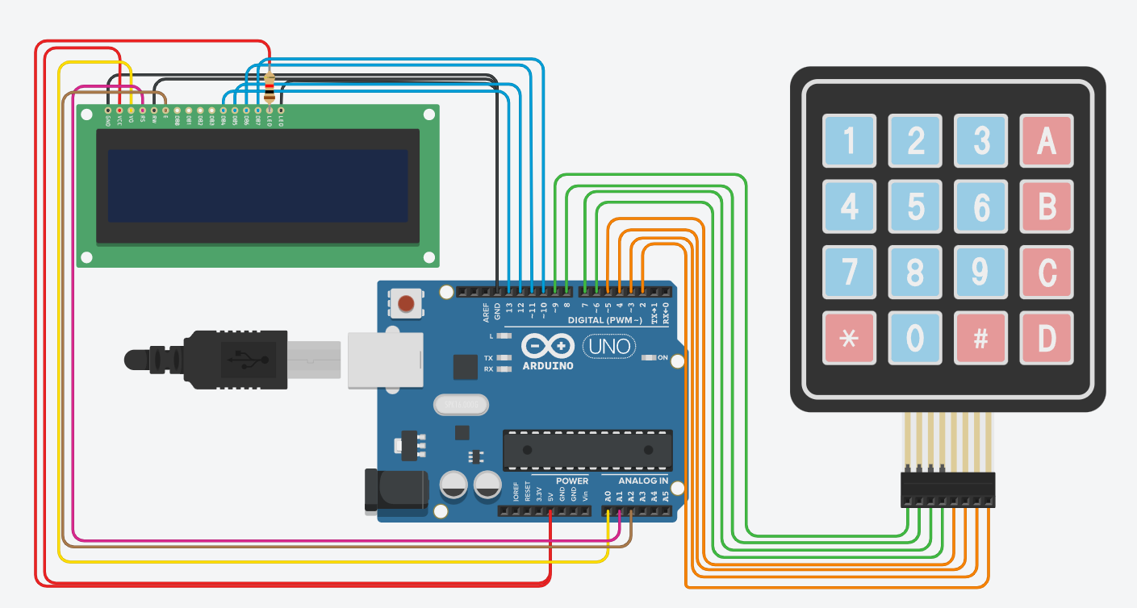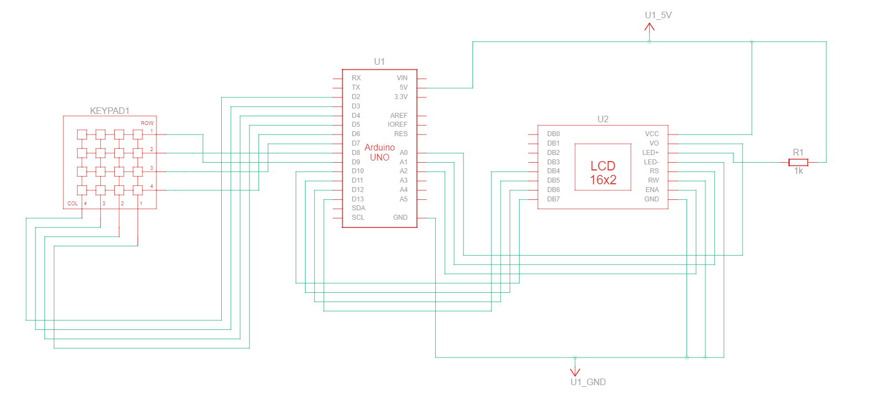
Conclusion
This calculator works well for simple one-digit math problems. It has limits (like crashing if you divide by zero) because it's designed for learning. The code is clean and shows how buttons and screens talk to each other. With small fixes, it could become even more useful.

References :
Keypad Calculator using LCD - Hackster.io

